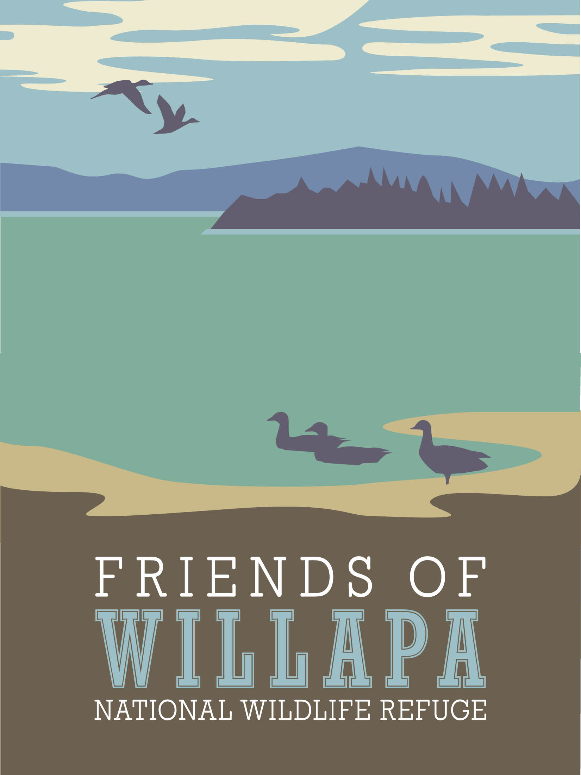

FRIENDS OF WILLAPA NATIONAL WILDLIFE REFUGE
Scholarship Application

To promote the preservation, awareness and appreciation of our environment, the Friends of Willapa National Wildlife Refuge offer a scholarship of $1,500 to students pursuing careers in fish and wildlife management, environmental education, conservation and related fields.

Personal Information
Name
Address
Date of Birth
Phone #

High School Information
High School Name
High School Address
Guidance Counselor Name
Guidance Counselor Phone #
Guidance Counselor Email
GPA*
* Also attach a complete high school transcript of grades and extracurricular activities including this semester’s coursework and extracurriculars.

College You Intend to Attend (you must notify us if this changes between your application and receipt of the scholarship)
College Name
Financial Aid Office Contact
FA Contact Phone #
FA Contact Email Address
Anticipated Major
Anticipated Minor
Student ID # (if available)

List wildlife/conservation/related activities and interests:

List of other scholarships applied for and/or received
Enter ‘None’ if you have not applied for or received any other scholarships
Scholarship Name | Date Received

The following items are required and must be received before the deadline of April 15. Applications not meeting all requirements or received late will not be considered.

- This completed application form
- Copy of the letter of acceptance to an accredited school
- A complete high school transcript of grades and extracurricular activities including the current semester’s coursework and extracurriculars. The extracurricular activities may be submitted as a separate document.
- Three (3) letters of recommendation, including one from your guidance counselor
- A typed 250- to 300-word essay about your anticipated future role in fish and wildlife management, environmental education/conservation, or related fields
.
Do not include materials that are not required.
Incomplete and/or late applications will not be considered.

Fully completed applications must be received by April 15th.

Email all materials to: scholarship@friendsofwillaparefuge.org
Or, if need be, mail to:
Scholarship Committee
FRIENDS OF WILLAPA NATIONAL WILDLIFE REFUGE
PO BOX 845
Ocean Park, WA 98640

