Thursday September 22
TAKING FLIGHT WELCOME SOCIAL
When: Thursday 5:30-8:00pm
Where: The Salt Hotel and Pub, 147 Howerton Ave, Ilwaco
Limit: 49
Cost: Free

Description: The Friends of Willapa National Wildlife Refuge (Friends) will kick off the annual Wings Over Willapa Festival on Thursday Evening September 22, at the Salt Hotel and Pub from 5:30pm to 8:00 pm. They are hosting a Welcome Social called Taking Flight. It will allow participants to mingle with each other and meet some of our local Artists who will have their work on display. The Salt Hotel and Pub will provide a cash bar and you can order from their menu. A great opportunity to get to know your fellow nature lovers, birders, artists, and many of the Friends staff.
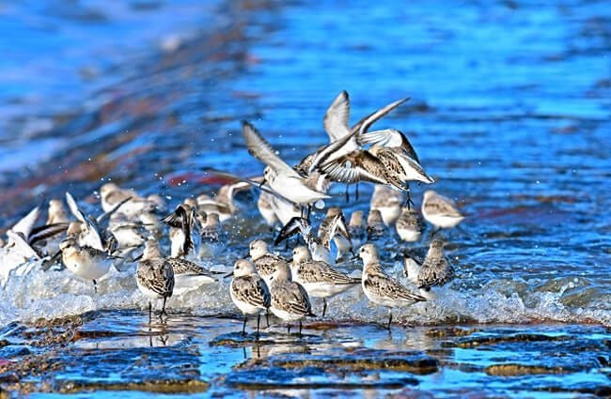

FRIDAY September 23
LEADBETTER ADVENTURE
When: Friday 8:00-11:00am
Where: Oysterville Road Beach Approach in Ocean Park
Limit: 10
Cost: $10
Birding in Pacific County Virtual Pass qualifying program! Download the pass and check-in during the program!

Description: Join the staff of Willapa National Wildlife Refuge for an exciting journey to the tip of the Long Beach Peninsula along to Leadbetter Point. This is a wild place with limited human access that creates a sanctuary for wildlife, rare plants, and hundreds of bird species, including the federally threatened western snowy plover and streaked horned lark. Bald eagles and peregrine falcons are often seen. Fall migration also brings dizzying concentrations of shorebirds to refuge shores. Participants will travel in 4x4 vehicles on the beach north from Oysterville Approach to the geographic tip of the peninsula. The guided tour will include opportunities for learning about the local ecology and ongoing habitat restoration activities.
- Participants must be able to get in and out of four-wheel drive vehicles.
- Participants must be able to walk in loose beach sand and uneven terrain for short distances.

Leader: Will Ritchie, Wildlife Biologist and Jennifer Orellana, Biological/Visitor Services Intern at Willapa NWR

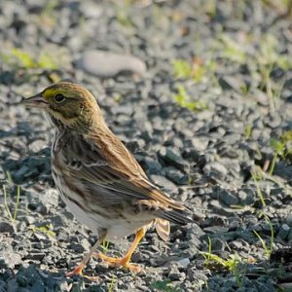

WILDLIFE TRACKING
When: Friday 8:30-10:30am
Where: Willapa NWR – Leadbetter Point, northern most parking area on Stackpole Road
Limit: 12
Cost: $10

Description: Join Kristi Freese, a Level 3 Wildlife Tracker, for a wildlife tracking hike at Leadbetter Point in Willapa National Wildlife Refuge. Kristi will provide a short presentation on tracking and you’ll set off along the shoreline of Willapa Bay to identify tracks of recent birds and mammals such as Sanderlings, Great Blue Herons, racoons, deer, and many other local wildlife species. Bring binoculars as there will be birding opportunities along the way.
- Washington State Discover Pass required for parking.
- This trip is rated as an easy hike along the shoreline of Willapa Bay. Terrain maybe uneven and wet.
Leader: Kristi Freese, Level 3 certified tracker CyberTracker International and Tracker Certification North America
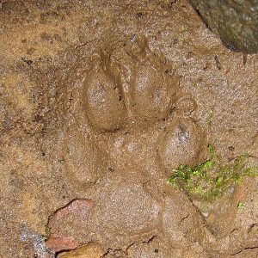

BIRDING BASICS: FINDING FOCUS
When: Friday 8:30-11:30am
Where: The Salt Hotel & Pub
Limit: 15
Cost: $10
Birding in Pacific County Virtual Pass qualifying program! Download the pass and check-in during the program!

Description: For beginners, identifying birds can seem overwhelming. Where do I start? What do I look at? Instinctually, most people gravitate toward noting the size and color of a bird. In this presentation at the Salt Hotel & Pub and follow up field trip around the Port of Ilwaco, professional bird enthusiast Ram Papish, will examine all the factors that aid identification.

Easy 1-2 mile walk on pavement.

Leader: Ram Papish is a tour guide, naturalist, environmental educator, and wildlife illustrator.
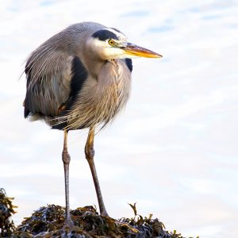

WAVES, TIDES AND CURRENTS WALK
When: Friday 10-11:00am
Where: Seaview Beach Approach on 38th Place in Seaview
Limit: 20
Cost: $5

Description: Explore the windswept beach ecosystem at the mouth of the Columbia River on this easy 1-hour walk with Interpretive Specialist Aaron Webster. We'll learn about how waves, tides, and currents combine in surprising ways to make this one of the most dangerous stretches of ocean on the planet. With views of the ocean, river mouth and dunes, this hike offers ample birding opportunities.

Easy 1 mile walk on wet sand.

Leader: Aaron Webster, Interpretive Specialist at Washington State Parks
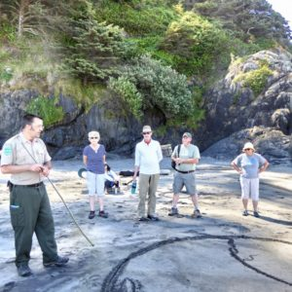

ELUSIVE, WILD CATERPILLAR SPOTTED
When: Saturday from 11am-12pm
Where: Willapa NWR Headquarters
Limit: 20
Cost: Free

Description: The size of this comma: , . That is the size of a newly hatched Oregon silverspot butterfly caterpillar. Finding this tiny federally-threatened caterpillar in the wild would be next to impossible – the ultimate little brown needle in a giant meadow haystack. However, if we could find them, then a door will be opened to a previous unknown understanding of at-risk pollinator species and prairie habitats. A conservation team comprise of Federal, University, State, non-profit and private partners – including Willapa National Wildlife Refuge – is making headway to start opening that door. Learn more about conservation projects linked to your coastal Washington backyard.

Leader: Samantha Derrenbacher, U.S. Fish and Wildlife Biologist
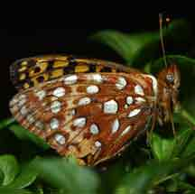

DISCOVERING LONG ISLAND
When: Friday 11am-4:30pm
Where: Willapa NWR - Cutthroat Creek (3888 Highway 101 Ilwaco, WA) located north of mile marker 24 on Highway 101
Cost: $25
Birding in Pacific County Virtual Pass qualifying program! Download the pass and check-in during the program!

Description: Looking for a longer hike and more time to discover Long Island, the largest estuarine island on the Pacific Coast and the ancient Cedar Grove with trees almost 1000 years old? Participants will be shuttled in small groups by boat from the Cutthroat Creek boat launch to the island every 15 minutes between 11:00am-1:00pm. The last boat shuttle back from the island will be at 4:30pm.
Once on the island, hike at your own pace 6 miles roundtrip through the heart of Long Island and the Ancient Cedar Grove, one of the last remnants of old growth coastal forest in southwest Washington. Discover information along the way from local experts.

- Participants must be able to walk on uneven terrain over a long distance (6 miles round trip). Trail is rated at moderate difficulty with some steep hills, exposed roots, etc.
- All participants MUST wear a Personal flotation device (PFD) on the boat. If you don't have a PFD, the Refuge will have some available.
- Wear all-weather clothing and appropriate footwear.
- Encouraged to bring water, snacks, binoculars, camera, and insect repellant.

Leader: Dawn Harris, Visitor Services Manager & Hope Presley, Visitor Services Specialist at Willapa NWR Complex
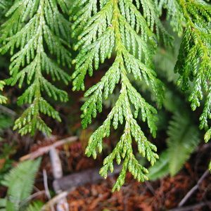

FROM FLOWERS TO FEATHERS
When: Friday 1-2:30pm
Where: Willapa NWR Refuge Headquarters, 7112 67th Place, Long Beach
Limit: 20
Cost: Free

Description: Is your garden or landscape optimized to attract our feathered friends? No matter how large or small, your yard and garden can support high-value habitat for birds, pollinators, and their food chains within the ecosystem. Come learn how to enhance (or transform!) your property with plantings and hardscape to better support the sheltering and nourishment of our winged visitors. Kelly Rupp, a local WSU Master Gardener, will share practical perspectives and inspiration to “just do it” for the birds!

Leader: Kelly Rupp, Washington State University Master Gardener
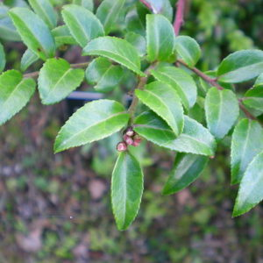

ELLSWORTH CREEK HIKE INTO THE GIANTS
When: Friday 1:00-3:00pm
Where: Willapa NWR - Cutthroat Creek (3888 Highway 101 Ilwaco, WA) located north of mile marker 24 on Highway 101
Limit: 10
Cost: $15

Description: Hike into the Ellsworth Creek Preserve in SW Willapa Bay. This is a 3.5-mile strenuous hike through an old growth Western Red Cedar and Sitka Spruce Forest to Ellsworth Creek. Along the way, Forest Manager Kyle Smith will share what The Nature Conservancy and the Willapa National Wildlife Refuge are doing to restore these lush forests.
- Participants meet at Willapa NWR - Cutthroat Creek parking area and carpool in 4x4 vehicles to Ellsworth Creek to begin their hike.
- Expect a strenuous hike (3.5 miles round trip) on uneven terrain in muddy, brushy, wet conditions but it’s worth it to see these giants.
- Wear all-weather clothing and sturdy hiking boots.
Leader: Kyle Smith, Forest Manager at The Nature Conservancy
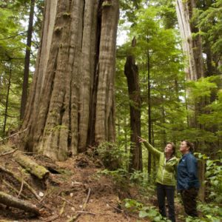
FEATHER RAKU POTTERY
When: Friday 2:00-4:00pm and Friday 4:00-6:00pm
Where: Brownlee Studio located at 4905 Sandridge Road Long Beach
Limit: 6
Cost: $35

Description: Roll up your shirtsleeves and join clay artist Karen Brownlee to create your own pottery masterpiece. Participants will use bird feathers and a technique called raku to create a unique design on your very own clay pot.

Leader: Karen Brownlee, clay artist

LOOMIS LAKE BEACH WALK
When: Friday 2:00-4:00pm
Where: Loomis Lake State Park, 184th Place Long Beach
Limit: 20
Cost: $35
Birding in Pacific County Virtual Pass qualifying program! Download the pass and check-in during the program!

Description: Long Beach is a popular spot for recreation, but it offers extra wonders for nature enthusiasts! Join naturalist Rebecca Lexa as she shares some of the secrets of the beach and dune ecosystems, and keep your eyes open for birds and other wildlife too. This hike will be about 2.5 miles round trip on uneven trail on the beach with loose or wet sand.

Leader: Rebecca Lexa, naturalist
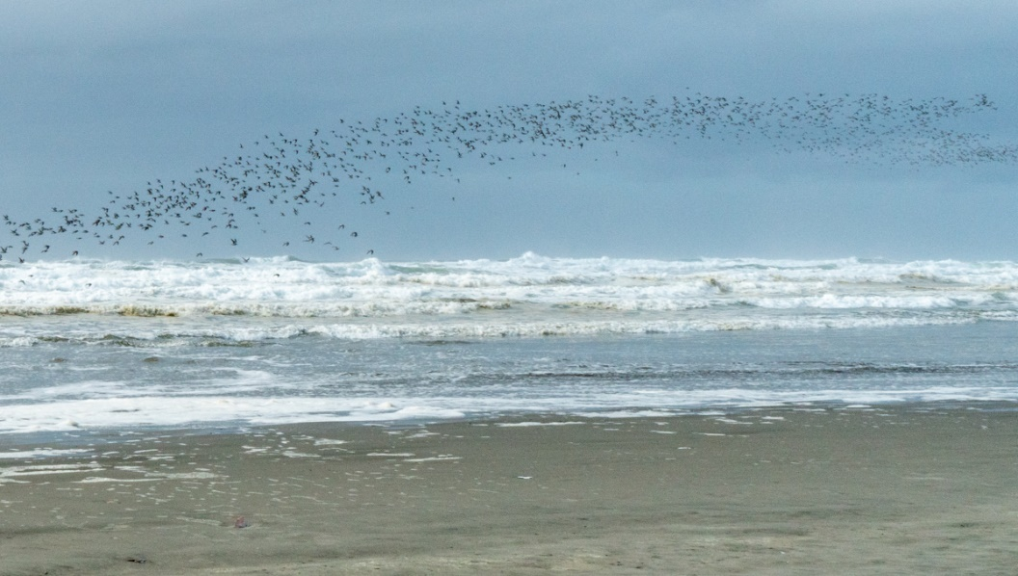

YOUR SHOREBIRDS COUNT: AN OVERVIEW OF MANOMET'S INTERNATIONAL SHOREBIRD SURVEY
When: Friday 3-4pm
Where: Willapa NWR Refuge Headquarters, 7112 67th Place, Long Beach
Limit: 20
Cost: Free

Description: In 1974, International Shorebird Survey (ISS) was launched as a Citizen Science project designed to gather information on shorebirds and the habitats they use, with dedicated and enthusiastic shore birders across the Western Hemisphere conducting surveys during migration. ISS has documented observations of more than 100 million shorebirds over 100,000+ surveys. Compiled data used by scientists and conservation partners have been fundamental for population size and trend analyses and formed the primary data source documenting wide-scale shorebird population declines.

Lisa will talk about how ISS fits into Manomet's work with shorebirds, some of its interesting history, how shorebird enthusiasts can contribute data, and how ISS data has been used in shorebird science and conservation.

Leader: Lisa Schibley, International Shorebird Survey Coordinator for Manomet
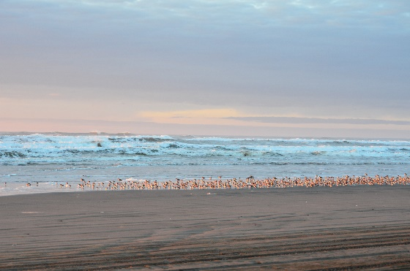

KEYNOTE: NOAH STRYCKER, BIRDING WITHOUT BORDERS
When: Friday 6:30-9pm
Where: Columbia Pacific Heritage Museum, 115 Lake St SE, Ilwaco
Limit: 49
Cost: $35

Description: The festival’s keynote speaker is Noah Stryker. Noah is an author, entertaining and knowledgeable lecturer, and expert birder, who in 2015 set a new record for the World Big Year of birding, seeing 6,042 species in a single year!! His inspiring presentation about this epic quest will leave you with a new appreciation for the birds and birders of the world. Light refreshments and a drink are included with registration. A cash bar will also be offered.

Leader: Noah Strycker
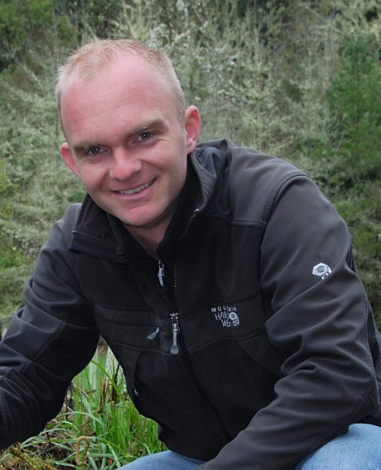

SATURDAY September 24
BIRDING BASICS: FINDING FOCUS
When: Saturday 8:30-11:30am
Where: Willapa NWR Refuge Headquarters, 7112 67th Place, Long Beach
Limit: 15
Cost: Free
Birding in Pacific County Virtual Pass qualifying program! Download the pass and check-in during the program!

Description: For beginners, identifying birds can seem overwhelming. Where do I start? What do I look at? Instinctually, most people gravitate toward noting the size and color of a bird. In this presentation at Willapa National Wildlife Headquarters and follow up field trip on Parker Slough Trail, professional bird enthusiast Ram Papish, will examine all the factors that aid identification.

Easy 1-2 mile walk on gravel trail with some small hills.

Leader: Ram Papish is a tour guide, naturalist, environmental educator, and wildlife illustrator.
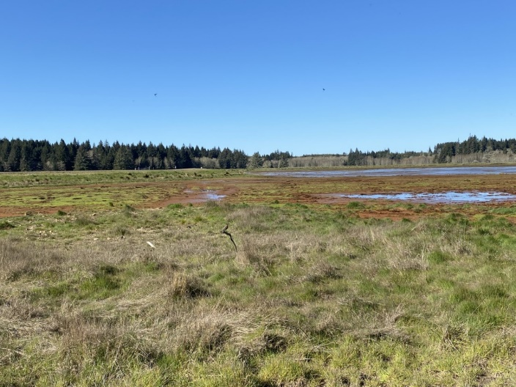

BIRDING WITH NOAH STRYCKER
When: Saturday 9am-12pm
Where: Oysterville Road Beach Approach in Ocean Park, WA
Limit: 25
Cost: $20
Birding in Pacific County Virtual Pass qualifying program! Download the pass and check-in during the program!

Description: Bird nerd Noah Strycker of Oregon became the first human to see more than half of the planet’s bird species in a single, year-long, round-the-world birding trip. Imagine what you will discover on this adventure! Begin with a hike on the beach next to the mighty Pacific Ocean to see a variety of shorebirds, gulls and raptors, and if lucky, a western snowy plover or two. Then you’ll hop back into your cars and migrate over to the northern Leadbetter Point parking area on Stackpole Road. The hike will continue on Bay Loop Trail on Willapa NWR, which provides viewing opportunities for a diversity of shorebirds, waterfowl and passerines along the shoreline of Willapa Bay and through a shore pine forest.
- Washington State Discover Pass required for parking.
- Easy 2–3-mile hike on both wet and loose sand and a nature trail.
- Bring your favorite pair of binoculars and scope (additional spotting scopes will be provided).

Leader: Noah Strycker, Wing Over Willapa keynote speaker and Dawn Harris, Visitor Services Manager at Willapa NWR Complex
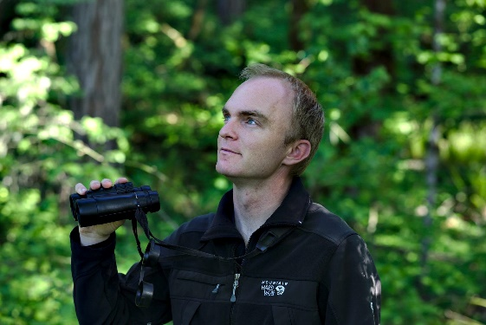

FOREST FOG HIKE
When: Saturday 10am-12pm
Where: Cape Disappointment State Park - Coastal Loop Trailhead on SR100 spur
Limit: 10
Cost: $5
Birding in Pacific County Virtual Pass qualifying program! Download the pass and check-in during the program!

Description: Delve into Cape Disappointment's old-growth forests for a moderate 2 hour (2 miles) guided walk with Parks Interpretive Specialist Aaron Webster. Participants will discover how this forest is part of a complex global system that keeps us all alive. With views of the river, estuary and the surrounding forest, birding opportunities abound so bring your binoculars. Meet at the Coastal Loop Trailhead on SR100spur, right across from the Cape D. Cafe.
- Washington State Discover Pass required for parking area.
- Trail is rated as moderate. Participants must be able to walk on uneven terrain 2 miles round trip.

Leader: Aaron Webster, Interpretive Specialist at Washington State Parks

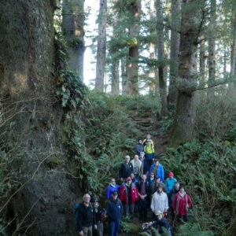

SHOREBIRD IDENTIFICATION
When: Saturday 10am -12pm
Where: Ocean Park Beach Approach on Bay Avenue in Ocean Park
Limit: 15
Cost: $5
Birding in Pacific County Virtual Pass qualifying program! Download the pass and check-in during the program!

Description: Shorebirds, some no larger than a sparrow, are among Earth’s great long-distant migrants. In autumn, witness a dazzling array of these birds as they make their way south from their Arctic breeding grounds. At first glance, all these little brown birds may look alike. But with a practice, you can identify different shorebird species like a pro. Join USFWS wildlife biologist Vanessa Loverti for a shorebird ID field trip and instruction to help you differentiate both local and migrant shorebirds by size, shape, color, and behavior.

Bring your favorite pair of binoculars and scopes (additional spotting scopes will be provided).

Leader: Vanessa Loverti, Regional Shorebird Coordinator for the US Fish and Wildlife Service

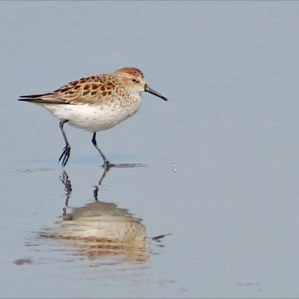

NATURE PLAY DAY
When: Saturday 10am-2pm
Where: Veterans Field 111 3rd St SE, Long Beach
Cost: Free

Description: Join this family friendly free event and take part in activities to learn about the diverse environment we live in here on the Long Beach Peninsula. Make your way through stations where you learn about the habitats and critters that live in them, get creative with recycled sculptures, build your own bird box, get your face painted and so much more!

Leader: Cheri Lloyd and Hope Presley, Visitor Services Specialist at Willapa NWR Complex

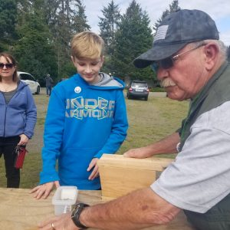

GLAZED AND AMAZED
When: Saturday 10:30 - 12:00
Where: Bay Avenue Gallery 1406 Bay Avenue, Ocean Park WA 98640
Limit: 10
Cost: $30

Description: Ready to glaze bird themed ceramics. Bring your creativity and have fun glazing a nature mug of your choice. This is a fun filled class for all ages. The participant can use a multitude of glazes to either freestyle their artwork or use a combination of stencils and other tools. If you've ever wanted to create your own glaze design and learn the process, this is the class for you. Participants will glaze their choice of ceramic artwork during class, then it will be fired in the kiln that night and ready to be picked up the following day.

Leader: Sue Raymond, owner of bay Avenue Gallery

FREE MOVIES AT NEPTUNE THEATER
When: Saturday 11am-1pm
Where: Neptune Theater 809 Ocean Beach Blvd S, Long Beach
Cost: Free

Description:
Disneynature Wings Of Life 1 h 20 min
Narrated by Meryl Streep, this intimate and unprecedented look at butterflies, hummingbirds, bees, bats and flowers is a celebration of life, as a third of the world’s food supply depends on these incredible – and increasingly threatened – creatures.

The Big Year – PG, 1h 40m
Staring Owen Wilson, Jack Black and Steve Martin.
Two bird enthusiasts try to defeat the cocky, cutthroat world record holder in a year-long bird-spotting competition.

LONG ISLAND EXPEDITION
When: Saturday 11am-3:30pm
Where: Willapa NWR - Cutthroat Creek (3888 Highway 101 Ilwaco, WA) located north of mile marker 24 on Highway 101
Limit: 49 (add up to 85 once we know about COVID later)
Cost: $25
Birding in Pacific County Virtual Pass qualifying program! Download the pass and check-in during the program!

Description: Join the staff of Willapa National Wildlife Refuge and Brian Atwater of the U.S. Geological Survey for an unforgettable expedition to Long Island, the largest estuary island on the Pacific Coast. Board the barge for a 40-minute voyage (each way) on Willapa Bay along the southern shoreline of the island. Arriving on the western side of the island near Smoky Hollow, you’ll begin a 2-mile round trip hike to the Ancient Cedar Grove. This 274-acre grove is one of the last remnants of the old growth coastal forest once common in SW Washington. Some of the western red cedar trees in the grove are over 1,000 years old. Brian will recount how Long Island old growth helped confirm Japanese dating of a prehistoric Cascadia earthquake Some of the western red cedar trees in the grove are over 1,000 years old.
- Participants must be able to walk on uneven terrain over a long distance (2 miles round trip). Trail is rated at moderate difficulty with some steep hills, exposed roots, etc.
- All participants MUST BRING and wear a Personal flotation device (PFD) on the boat. If you don't have a PFD, the Refuge will have some available.
- Wear all-weather clothing and appropriate footwear.
- Encouraged to bring water, snacks, binoculars, camera, and insect repellant.

Leader: Matt Lloyd, Deputy Project Leader at Willapa NWR and Brian Atwater, Scientist emeritus, U.S. Geological Survey and Affiliate professor, University of Washington

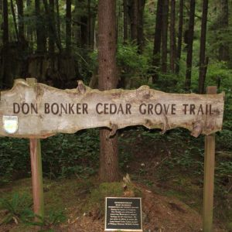

SUNDAY September 25
LEADBETTER ADVENTURE
When: Sunday 8-11am
Where: Oysterville Road Beach Approach in Ocean Park
Limit: 10
Cost: $10
Birding in Pacific County Virtual Pass qualifying program! Download the pass and check-in during the program!

Description: Join the staff of Willapa National Wildlife Refuge for an exciting journey to the tip of the Long Beach Peninsula along to Leadbetter Point. This is a wild place with limited human access that creates a sanctuary for wildlife, rare plants, hundreds of bird species, including the federally threatened western snowy plover and streaked horned lark. Bald eagles and peregrine falcons are often seen. Fall migration also brings dizzying concentrations of shorebirds to refuge shores. Participants will travel in 4x4 vehicles on the beach north from Oysterville Approach to the geographic tip of the peninsula. The guided tour will include opportunities for learning about the local ecology and ongoing habitat restoration activities.
What to know: Participants must be able to:

- Get in and out of four-wheel drive vehicles.
- To walk in loose beach sand and uneven terrain for short distances.

Leader: Will Ritchie, Wildlife Biologist and Kelsey Lotz, Biological Technician at Willapa NWR
LeadbetterAdv2
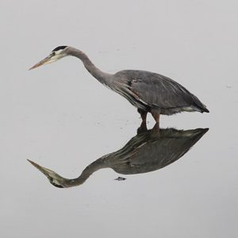

ADVENTURES FOR YOUNG BIRDERS
When: Sunday 9-11am
Where: Seaview Beach Approach on 38th Place in Seaview
Limit: 12
Cost: $5
Birding in Pacific County Virtual Pass qualifying program! Download the pass and check-in during the program!

Description: This field trip, exclusively for young naturalists in Elementary or Middle school, will follow the path of the Long Beach Discovery Trail. A wonderful and easily accessible trail, the Discovery Trail traverses the coastal habitats of the Pacific Northwest home to a unique variety of birds. Together with experienced young birder, Rowan Young-McMurchie, participants will learn the basics of birding and techniques for identifying different bird species on an easy-to-moderate hike while seeing many birds and having fun along the way. Parents are welcomed and recommended with younger children.

- All walking abilities welcome. Paved, and unpaved areas of trail, generally an easy to moderate walk of 1-3 miles.
- We encourage you to explore eBird (https://ebird.org/home) before the field trip so you can either keep lists or just learn about eBird.

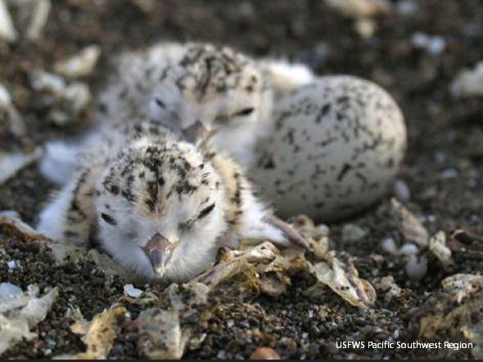
Leader: Rowan Young McMurchie
WILD LANDSCAPING
When: Sunday 10-11am
Where: Willapa NWR Refuge Headquarters, 7112 67th Place, Long Beach
Limit: 15
Cost: Free

Description: The plants you select matter when constructing landscapes for wildlife. Join Kathleen Sayce for a walk around the site to learn about what species are going where, and what the new office landscape will look like in years to come. Native plants will be featured to enhance insect and pollinator diversity, which improves habitat for birds and other wildlife. The wild lawn is a mix of naturally low growing grasses and perennials; all can take one fall mowing per year and thrive. For details and plant lists, come and tour the new site.

Leader: Kathleen Sayce, naturalist

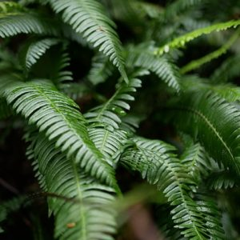

SHOREBIRD IDENTIFICATION
When: Sunday 10am -12pm
Where: Ocean Park Beach Approach on Bay Avenue in Ocean Park
Limit: 15
Cost: $5
Birding in Pacific County Virtual Pass qualifying program! Download the pass and check-in during the program!

Description: Shorebirds, some no larger than a sparrow, are among Earth’s great long-distant migrants. In autumn, witness a dazzling array of these birds as they make their way south from their Arctic breeding grounds. At first glance, all these little brown birds may look alike. But with a little practice, you can identify different shorebird species like a pro. Join USFWS wildlife biologist Vanessa Loverti for a shorebird ID field trip and instruction to help you differentiate both local and migrant shorebirds by size, shape, color, and behavior.

What to Bring: Bring your favorite pair of binoculars and scopes (additional spotting scopes will be provided).

Leader: Vanessa Loverti, Regional Shorebird Coordinator for the US Fish and Wildlife Service

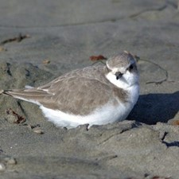
SOUTH BAY Eco-Exploration
When: Sunday 10am-12pm
Where: Willapa NWR – Tarlatt located at the east end of 95th Street in Long Beach, WA
Limit: 20
Cost: Free
Birding in Pacific County Virtual Pass qualifying program! Download the pass and check-in during the program!

Description: The South Bay of Willapa NWR offers a variety of ecosystems within close proximity to each other. On this walk led by naturalist Rebecca Lexa you'll get to explore meadows, forests, tidal estuaries, and more! This will be a 2-mile hike on an easy gravel trail with one steep hill.

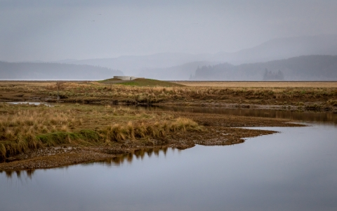
Leader: Rebecca Lexa, naturalist

WOODLAND STREAM NEEDLE FELTING
When: Sunday 11am-1pm
Where: North Jetty Brewery 4200 Pacific Way, Seaview, WA
Limit: 6
Cost: $35

Description: Learn to ‘paint’ a beautiful woodland landscape with wool. Participants will learn basic skills and complete a landscape in a step-by-step workshop. This workshop is suitable for beginners, but also enjoyable for an experienced felter. Participants will leave with a beautiful work of art ready to be displayed. Included in Cost: printed diagram, two color-coded felting needles, felting wool, wool fabric backing, high quality 7-inch wooden hoop, and felting foam mat surface.

Leader: Cheri Lloyd
